Justin Cabral

CS-542

Database Management Systems

Homework #1

**Problem 1 (Car-Race Database)**

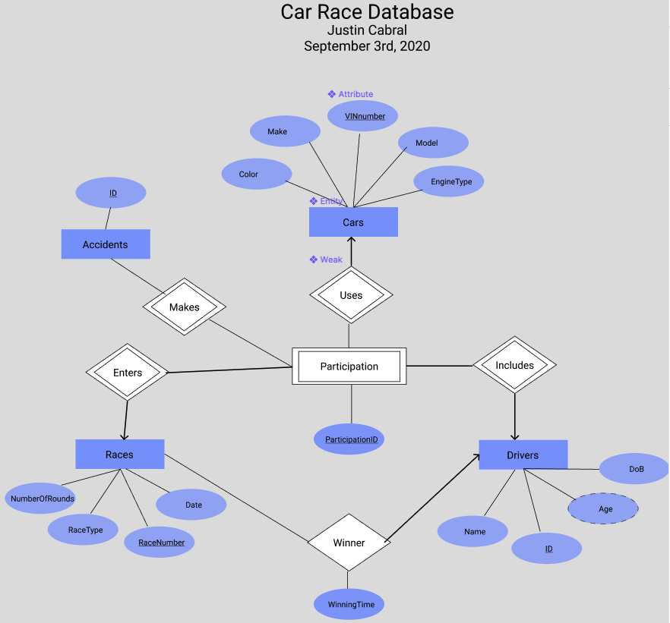

* For the 3 given entity sets: Drivers, Cars and Racers, I created a weak entity, Participation, that shares a weak relationship with the other entities. This was done to separate future many-to-many relationships into one-to-many relationships.
* One car can be included in many Participations
* One race can have many participants enter
* One driver can be included in many Participations.
* I use the participation ID to tell which car is used by a given driver in a certain race. This way we can link the use cases to a specific participation.
* For when accidents are made, I relate it to the participation of which entities were involved. Each accident has an ID attribute distinguishing each accident.
* For the Winner relation, I made it one-to-many because one driver can win many races, but every race can only have one winner.

**Problem 2 (Mini-Store Database)**

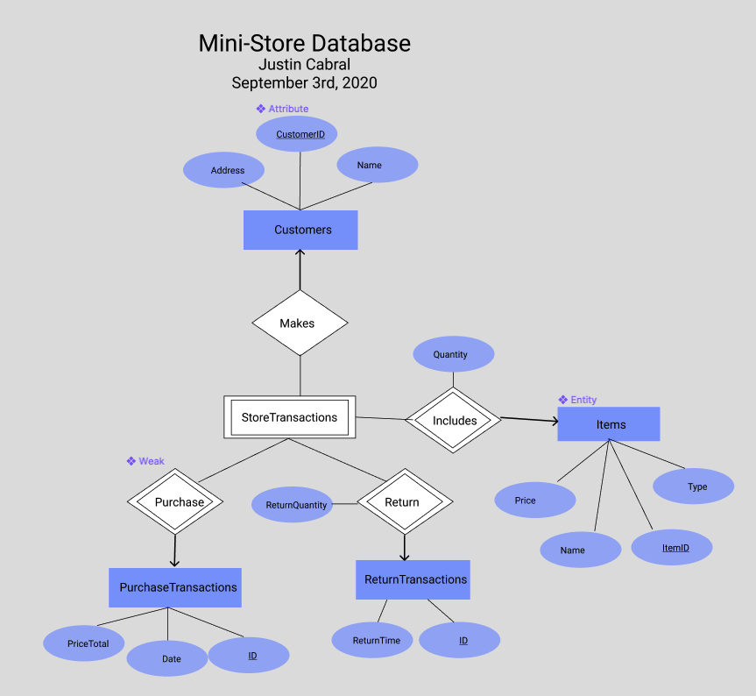

Relations between each entity set:

* One customer can make many store transactions.
* One item is included in many store transactions.
* One purchase transaction can be part of many store transactions.
* One return transaction can be part of many store transactions.
* Return quantity attribute relates its relationship with a store transaction

The Store Transactions weak entity is used to track which item is returned in a specific return transaction, given its return quantity and return time. The entity also used to track specific purchase transactions, along with the customer who is making the transaction.